3. Your First Visual Basic Express Project


Review and Preview

In the first two classes, you learned about forms, controls, properties, and event procedures. In this class, you’re going to put that knowledge to work in building your first simple Visual Basic Express project. You’ll learn the steps in building a project, how to put controls on a form, how to set properties for those controls, and how to write your own event procedures using a little BASIC.

Steps in Building a Visual Basic Express Project

There are three primary steps in building a Visual Basic Express Project:

- Place (or draw) controls on the form.
- Assign properties to the controls.
- Write event procedures for the controls.

Each of these steps is done with Visual Basic Express in design mode.

Start Visual Basic Express and start a new project (review the steps covered in Class 2, if necessary, naming it whatever you choose). Open the created form in the Design window. You should see something like this:

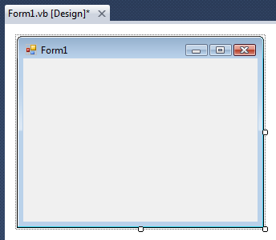
Sizing handle
Notice the form has a ‘sizing handle’ in the lower right corner. You can resize the form if you want. This is one of the ‘Windows’ techniques you should be familiar with. If you move the cursor over this handle, a little ‘double-arrow’ will appear. At that point, you can click and drag the corner to its desired position. This allows you to increase the width and height of the form at the same time. If you hold the cursor over the right or lower edge (until the arrow appears), you can resize the width and height, respectively. Practice sizing the form.

Placing Controls on the Form

The first step in building a Visual Basic Express project is to place controls on the form in their desired positions. So, at this point, you must have decided what controls you will need to build your project. Many times, this is a time-consuming task in itself. And, I guarantee, you will change your mind many times. Right now, we’ll just practice putting controls on the form.

Controls are selected from the Visual Basic Express Toolbox window (Windows Form controls). Click a tool in the toolbox and hold the mouse button down. Drag the selected tool over to the form. When the cursor pointer is at the desired upper left corner, release the mouse button and the default size control will appear. This is the classic “drag and drop” operation. (There are other ways to put controls on the form, but we’ll just use this one). Once the control is on the form, you can still move or resize the control. To move a control, left-click the control to select it (crossed-arrows will appear). Drag it to the new location, then release the mouse button. To resize a control, left-click the control so that it is selected. If you move the cursor over one its four sizing handles, a little ‘double-arrow’ will appear. At that point, you can click and drag the corresponding edge or corner to its desired position.
Example

Make sure Visual Basic Express is still running and there is a form on the screen as well as the Toolbox (click View on the main menu, then Toolbox if it is not there). Go to the toolbox and find the button control. It looks like this:

Drag and drop the button onto the form. Your form should look something like this:

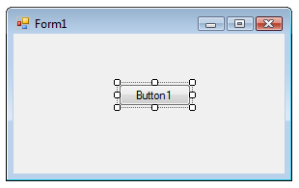

Notice the sizing handles around the button. This indicates this is the active control. Click on the form and those handles disappear, indicating the form is now the active control. Click on the button again to make it active.

As mentioned, controls can always be moved and resized. To move a control you have drawn, click the object on the form (a cross with arrows will appear). Now, drag the control to the new location. Release the mouse button. To resize a control, click the control so that it is selected (active) and sizing handles appear. Use these handles to resize the object.

Click here to move object
Use sizing handles to resize control
Move the button around and try resizing it. Make a real big button, a real short button, a real wide button, a real tall button. Try moving the button around on the form.

Drag and drop another button control on the form. Move and resize it. Click from button to button noticing the last clicked control has the sizing handles, making it the active control. Spend some time placing controls on the form. Use other controls like labels, text boxes, radio buttons, and check boxes. Move them around, resize them (you won’t be able to resize label controls). Try to organize your controls in nicely lined-up groups. These are skills that will be needed in building Visual Basic Express projects.

You also need to know how to remove controls from a form. It is an easy process. Click on the control you want to remove. It will become the active control. Press the Del (delete) key on your keyboard. The control will be removed. Before you delete a control, make sure you really want to delete it.
Setting Control Properties (Design Mode)

Once you have the desired controls on the form, you will want to assign properties to the controls. Recall properties specify how a control appears on the form. They establish such things as control size, color, what a control ‘says’, and position on the form. When you place a control on the form, it is given a set of default properties by Visual Basic Express. In particular, its geometric properties (governing size and location) are set when you place and size the control on the form. But, many times, the default properties are not acceptable and you will want to change them. This is done using the Properties Window.

If Visual Basic Express is not running on your computer, start it now. Start another new project. There should be a blank form in the design window. If it’s not there, select the View menu and choose Designer. Find the Properties Window (press <F4> if it’s not there):

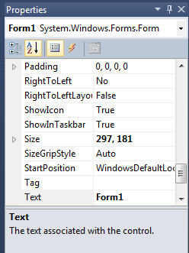
Click the Alphabetic view (the button with A-Z on it) if Categorized properties are displayed. Also make sure the Properties button, next to the Alphabetic view button is depressed (always make sure this button is pressed when working with properties). Recall the box at the top of the properties window is the control list, telling us which controls are present on the form. Right now, the list only has one control, that being the form itself. Let’s look at some of the form’s properties.

First, how big is the form? All controls are rectangular in shape and two properties define the size of that rectangle. Scroll down the list of properties and find the Size property. You will see two numbers listed separated by commas. The first number is the Width of the form in pixels (a pixel is a single dot on the form). The second number is the Height of the form in pixels. Click on the little plus sign (+) in the box next to the Size property. The Width and Height properties will be displayed individually. Resize the form and notice the Height and Width properties change accordingly. You can also change the width and height of the form by typing in values for the desired property in the Properties window. Try it.

Scroll to the BackColor property. You probably guessed that this sets the background color of the form. The value listed for that property is probably Control (a light gray). To change the BackColor property, click on BackColor, then on the drop-down arrow that appears in the property side of the list. Choose one of the three ‘tabs’ that appear: Custom, Web, or System, then choose a color. My favorite is Custom. With this choice, a palette of colors will appear, you can choose a new color and notice the results.

Scroll to the Text property. This property establishes what is displayed in the form’s title bar. Click on Text, then type in something on the right side of the property window and press <Enter>. Notice the new Text appears in the form title bar.

That’s all there is to setting control properties. First, select the control of interest from the control list. Then, scroll down through properties and find the property you want to change. Click on that property. Properties may be changed by typing in a new value (like the Width and Height values and the Text property) or choosing from a list of predefined options (available as a drop-down list, like color values).

Let’s look at some of the button properties. Add a button control to your form. Select the button in the control list of the properties window. Like the form, the button is also rectangular. Scroll down to the Size property and click on the little plus (+) sign to expand this property. The Width property gives its width in pixels and Height gives its height in pixels. Two other properties specify the location of the button on the form. Scroll down to the Location property and expand it. Values for X (the Left property) and Y (the Top property) are displayed. Left gives the horizontal position (in pixels) of the left side of the button relative to the left side of the form. Similarly, Top is the vertical position (in pixels) of the top side of the button relative to the top of the form (the top of the form being defined as the lower part of the title bar). For a single button, these properties are:

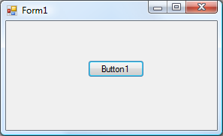
Top
Left
Height
Width
Another important property for a button is the Text property. The text appearing on the button is the Text. It should indicate what happens if you click that button. Change the Text property of your button. Put a couple more buttons on the form. Move and size them. Change their Text and BackColor properties, if you want.

We have seen that to change from one control to another in the properties window, we can click on the down arrow in the controls list and pick the desired control. A shortcut method for switching the listed properties to a desired control is to simply click on the control on the form, making it the active control. Click on one of the buttons. Notice the selected control in the properties window changes to that control. Click on another button - note the change. Click on the form. The selected control becomes the form. You will find this shortcut method of switching from one control to another very useful as you build your own Visual Basic Express projects.

Naming Controls

The most important property for any control is its Name. Because of its importance, we address it separately. When we name a control, we want to specify two pieces of information: the type of control and the purpose of the control. Such naming will make our programming tasks much easier.

In the Visual Basic programming community, a rule has been developed for naming controls. The first three letters of the control name (called a prefix) specify the type of control. Some of these prefixes are (we will see more throughout the class):

Control Prefix
Button btn
Label lbl
Text Box txt
Check Box chk
Radio Button rdo

After the control name prefix, we choose a name (it usually starts with an upper case letter to show the prefix has ended) that indicates what the control does. The complete control name can have up to 40 characters. The name must start with a letter (this is taken care of by using prefixes) and can only contain letters (lower or upper case), numbers, and the underscore (_) character. Even though you can have 40 character control names, keep the names as short as possible without letting them lose their meaning. This will save you lots of typing.

Let’s look at some example control names to give you an idea of how to choose names. These are names used in the Sample project looked at in Class 1 and Class 2. Examples:

btnBeep - Button that causes a beep
txtType- Text box where information could be typed
rdoBlue - Radio button that changes background color to Blue
chkTop - Check box that displays or hides the toy top
picTop – Picture box that has the picture of a toy top

This should give you an idea of how to pick control names. We can’t emphasize enough the importance of choosing proper names. It will make your work as a programmer much easier.

Note that, unlike most programming languages, the Visual Basic language is not case sensitive. This means the names picTop and PICTOP are treated the same. Make sure you assign unique names to each control. Even though, Visual Basic Express is case insensitive, we still suggest mixing upper and lower case letters in your control names for improved readability.

Setting Properties in Run Mode

To illustrate the importance of proper control names, let’s look at a common task in Visual Basic Express. We have seen one of the steps in developing a Visual Basic Express project is to establish control properties in design mode. You can also establish or change properties while your project is in run mode. For example, in the Sample project, when you clicked on a radio button, the BackColor property of the form was changed. When you clicked on a food name, that food either appeared or disappeared. To change a property in run mode, we need to use a line of BASIC code (you’re about to learn your first line of BASIC!). The format for this code is:

ControlName.PropertyName = PropertyValue

That is, we type the control’s name, a dot (same as a period or decimal point), the name of the property we are changing (found in the properties window), an equal sign (called an assignment operator), and the new value. Such a format is referred to as dot notation.

In Sample, the code used to display the burger on the form is:

picBurger.Visible = True

The Visible property of a control can be True (control is displayed) or False (control is not displayed). Notice proper control naming makes this line of code very understandable, even if you don’t know any BASIC. It says that the picture box displaying the burger has been made visible.

One exception to the rule we just used is when we set Form properties. To set a form property at run-time, you use the Visual Basic Express keyword Me to refer to the form. For example, in Sample, to set the background color of the form to blue, we use:

Me.BackColor = Color.Blue

How Control Names are Used in Event Procedures

Another place the importance of proper control naming becomes apparent is when we write event procedures (discussed next). When you put a control on a form, all of the possible event procedures that control can have are added to your project. We have seen that these event procedures are viewed in the code window. The structure for these event procedures is:

Private Sub ControlName_EventName(ByVal sender As System.Object, ByVal e As System.EventArgs) Handles ControlName.EventName

Header

[BASIC code goes here]

Footer

End Sub

There’s a lot to look at. The first, very long line that takes up three lines here, is the header line. The last line is the footer line. The actual BASIC code goes between these two lines. Let’s look at the header, ignoring the information in parentheses for now. Notice the control name is used twice in this header line, as is the event name. The key thing to notice is that, with proper naming, we can easily identify each control’s event procedure.

As an example, using Sample again, the CheckedChanged event procedure for the rdoBlue control is:

Private Sub rdoBlue_CheckedChanged(ByVal sender As System.Object, ByVal e As System.EventArgs) Handles rdoBlue.CheckedChanged
'Change form color to blue
Me.BackColor = Color.Blue
End Sub

We recognize this is the code that is executed when the user changes the Checked property (clicks on) of the rdoBlue radio button. Proper naming makes identifying and reading event procedures very easy. Again, this will make your job as a programmer much easier. Now, let’s write our first event procedure.

Writing Event Procedures

The third step in building a Visual Basic Express application is to write event procedures for the controls on the form. To write an event procedure, we use the code window. Review ways to display the code window in your project. This step is where we need to actually write BASIC code or do computer programming. You won’t learn a lot of BASIC right now, but just learn the process of finding event procedures and typing code.

As just mentioned, when you place a control on a form, the event procedures associated with that control become part of the project and can be accessed using the code window. Each control has many event procedures. You don’t write BASIC code for each procedure - only the ones you want the computer to respond to. Once you decide an event is to be ‘coded,’ you decide what you want to happen in that event procedure and translate those desires into actual lines of BASIC code. As seen earlier, the format for each event procedure is:

Private Sub ControlName_EventName(ByVal sender As System.Object, ByVal e As System.EventArgs) Handles ControlName.EventName

[BASIC code goes here]

End Sub

In the header line (remember it’s one very long line), the words ‘Private Sub’ indicate this is a Subroutine (another word for procedure) that is Private to the form (only usable by the form - don’t worry about what this means right now). The words enclosed in parentheses tell us what information is provided to the event procedure. These values are known as the procedure arguments and we won’t concern ourselves with them right now. Lastly, the word Handles tells us just what event is ‘handled’ by this procedure. The code goes between this header line and the footer line (End Sub).

Writing the BASIC code is the creative portion of developing a Visual Basic Express application. And, it is also where you need to be very exact. Misspellings, missing punctuation, and missing operators will make your programs inoperable. You will find that writing a computer program requires exactness. So, the process to write event procedures is then:

- Decide which events you want to have some response to
- Decide what you want that response to be
- Translate that response into BASIC code
- Find the event procedure in the code window
- Type in the BASIC code

And, it is a process best illustrated by example. This example project is saved as FirstCode in the course projects folder (\BeginVBE\BVBE Projects).

Example

If Visual Basic Express is not running on your computer, start it and begin a new project. Name it FirstCode.

- Put a single button on the form.
- Set the Text property of the form to My First Code.
- Set the Name property of the button to btnBeep.
- Set the Text property of the button to Beep!!

At this point in the design process, your form should look something like this:

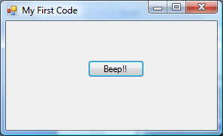

We want to write a single event procedure - the procedure that responds to the Click event of the button. When we click on that button, we want to computer to make a beep sound.

Display the code window (pressing <F7> is one way; choose View, then Code in the menu is another):

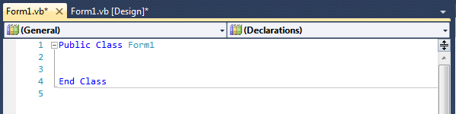

Your code window may not look like this. For example, there are numbers next to each line of code in my code window. You will find it very helpful to have such numbers. To add them, select the Tools menu item. Then, choose Options. In the left side of the window that appears, choose Text Editor, then Basic, then General. Then, choose the Line Numbers option.

The header line (Public Class Form1) starts the code and the footer line (End Class) ends the code. In Visual Basic Express, your project is called a class – these lines say you’re working with the class named Form1. These lines must remain. Any code you write needs to go between the two lines displayed in the code window.
Click on the Object list’s drop-down arrow and select btnBeep (the button). Click on the Procedures list and choose Click. The code window should now look like:
Event procedure
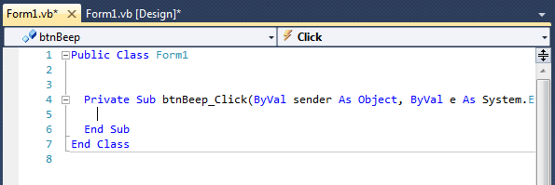
Type code here

Notice the Click procedure for the btnBeep button is now displayed This is where we type the code to make the computer beep.

The code window acts like a word processor. You can type text in the window and use many of the normal editing features like cut, paste, copy, find, and replace. As you become a more proficient programmer, you will become comfortable with using the code window. Click on the region between the header and footer lines. Between the header and footer lines, type the single line:

Beep

The code window should now look like this:

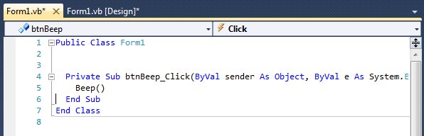

Notice after you typed the line, it was indented and parentheses were added at the end (indicating this is a built-in function). The Visual Basic Express environment does this additional ‘formatting.’ The keyword Beep is a BASIC instruction that tells the computer to beep. You have now written your first line of BASIC code.

Your project is now ready to run. Run the project (click the Start button on the toolbar or press <F5>). The form will appear:

(If it doesn’t, go back and make sure you’ve done all steps properly). Click the button. The computer should beep or some sound like a beep should be heard. You caused a Click event on the btnBeep control. The computer recognized this and went to the btnBeep_Click event procedure. There it interpreted the line of code (Beep) and made the computer beep. Stop your project. Go back to the code window and find the btnBeep_Click event. After the Beep line, add this line:

btnBeep.BackColor = Color.Blue

Make sure you type it in exactly as shown – code in computer programs must be exact. Run the project again. Click on the button. Explain what happens in relation to the control, the event procedure, and the BASIC code. Stop your project.

You may have noticed when you added this second line of code that as soon as you typed btnBeep, then a dot, a little window popped up with lots of choices for completing the line (BackColor was one of them). Similarly, once you pressed the equals sign (=), a choice of colors (including Color.Blue) popped up. This is the Visual Basic Express Intellisense feature. It helps a lot when it comes to typing code. Intellisense is a very useful part of Visual Basic Express. You should become acquainted with its use and how to select suggested values. You usually just scroll down the list (you can type the first few letters of a choice for faster scrolling), pick the desired item and continue typing. The choice will be inserted in the proper location. We tell you about the Intellisense feature now so you won’t be surprised when little boxes start popping up as you type code.
Summary

You have now finished your first complete Visual Basic Express project. You followed the three steps of building an application:

- Place controls on the form
- Assign control properties
- Write control event procedures

You follow these same steps, whether building a very simple project like the one here or a very complicated project.

Now, knowing these steps, you’re ready to start working your way through the Visual Basic Express toolbox, learning what each control does. You can now begin learning elements of the BASIC language to help you write programs. And, you can begin learning new features of the Visual Basic Express environment to aid you in project development. In each subsequent class, you will do just that: learn some new controls, learn some BASIC, and learn more about Visual Basic Express.

